## **Yash Rohan**

## **22-46636-1**

**CASE STUDY**

A power management system DESCO provides connection to the Users. Where Desco has licensees number, location, stock sales and communication. The systems also stores connection id,connection name, connection disconnection phase , connection date . There may be multiple connection date. It manages also clearance. The systems conduct the payment process by pre-paid and post-paid. Pre-paid process done by mobile banking, internet banking and post-paid process done by Desco mobile app, mobile banking, credit /debit banking. Desco also ensures providing service. There are three types of services: citizens service, internal service and institutional service. Moreover, the system manages users, to identify by user id,User name, email, user phone, user addresses. There may be multiple phone number. A user address is composed of house number and street name. A user-name also composed of first name and last name. Every user has login ID. By this id they can join by online. Username and password are mandatory aspects of logging in. On the other hand, there are employees who works for Desco. Employee can recognize distinct employee ids. Employee name, phone number, and addresses are also included. House number and street name is a part of address.

**ER DIAGRAM**

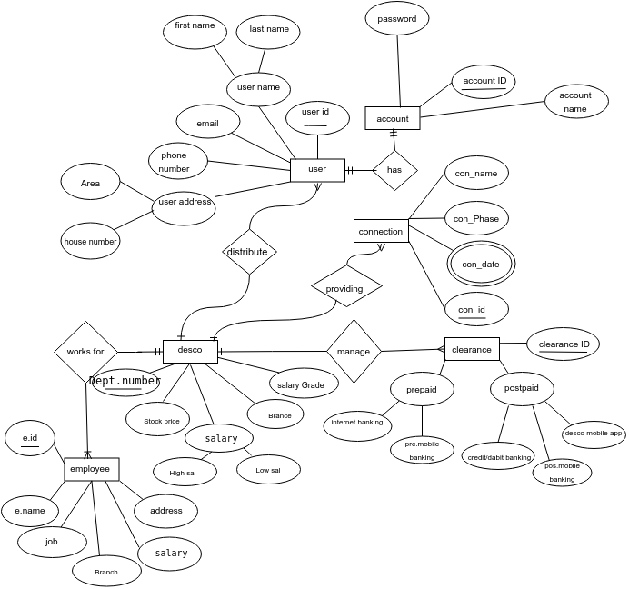

**NORMALIZATION**

**WORKS FOR:**

**UNF🡪 1st:**  E.ID, E. Name, Job, Branch, Salary, Address, Dept number, Stock price, High Salary, Low Salary, Branch, Salary Grade

**1NF🡪 1st:**  E.ID, Dept number, E. Name, Job, Branch, Salary, Address, Stock price, High Salary, Low Salary, Branch, Salary Grade

**2NF 🡪 1st:**  E.ID, E. Name, Job, Branch, Salary, Address, **Dept number**

**2NF 🡪 2nd:**  Dept number, Stock price, High Salary, Low Salary, Branch, Salary Grade

**3NF🡪** NO TRANSITIVE DEPENDENCIES

**3NF 🡪 1st:**  E.ID, E. Name, Job, Branch, Salary, Address, **Dept number**

**3NF 🡪 2nd:**  Dept number, Stock price, High Salary, Low Salary, Branch, Salary Grade

**HAS:**

**UNF🡪** User id, First name, Last name, Email, Phone Number, Area, House number, Account ID, Password, Account Name

**1NF🡪1st:**  User id, Phone Number, Account ID, First name, Last name, Email, Area, House number, Password,Account Name

**2NF🡪1st:**  User id, Phone Number, First name, Last name, Email, Area, House number

**2NF🡪2nd:**  Account ID, Password, Account Name, **User id**

**3NF🡪**NO TRANSITIVE DEPENDENCIES

**3NF🡪1st:**  User id, Phone Number, First name, Last name, Email, Area, House number

**3NF🡪2nd:**  Account ID, Password, Account Name, **User id**

**DISTRIBUTE:**

**UNF🡪** Dept number, Stock price, High Salary, Low Salary, Branch, Salary Grade, User id, First name, Last name, Email, Phone Number, Area, House number

**1NF 🡪1st:** Dept number, User id, Phone Number, Stock price, High Salary, Low Salary, Branch, Salary Grade, First name, Last name, Email, Area, House number

**2NF 🡪1st:** Dept number, Stock price, High Salary, Low Salary, Branch, Salary Grade

**2NF 🡪2nd:** User id, Phone Number, First name, Last name, Email, Area, House number**, Dept number**

**3NF🡪** NO TRANSITIVE DEPENDENCIES

**3NF 🡪1st:** Dept number, Stock price, High Salary, Low Salary, Branch, Salary Grade

**3NF 🡪2nd:** User id, Phone Number, First name, Last name, Email, Area, House number**, Dept number**

**PROVIDING:**

**UNF🡪** Dept number, Stock price, High Salary, Low Salary, Branch, Salary Grade, Con.ID, Con date, Con Phase, Con name

**1NF 🡪1st:** Dept number, Con.ID, Con date, Stock price, High Salary, Low Salary, Branch, Salary Grade, Con Phase, Con name

**2NF 🡪1st:**  Dept number, Stock price, High Salary, Low Salary, Branch, Salary Grade

**2NF 🡪2nd:**  Con.ID, Con date, Con Phase, Con name, **Dept number**

**3NF🡪** NO TRANSITIVE DEPENDENCIES

**3NF 🡪1st:**  Dept number, Stock price, High Salary, Low Salary, Branch, Salary Grade

**3NF 🡪2nd:**  Con.ID, Con date, Con Phase, Con name, **Dept number**

**MANAGE:**

**UNF🡪** Dept number, Stock price, High Salary, Low Salary, Branch, Salary Grade, C.ID, Desco M app, Mobile banking, Credit/Debit banking, M banking, Int banking

**1NF 🡪1st:** Dept number, C.ID, Stock price, High Salary, Low Salary, Branch, Salary Grade, Desco M app, Mobile banking, Credit/Debit banking, M banking, Int banking

**2NF 🡪1st:** Dept number, Stock price, High Salary, Low Salary, Branch, Salary Grade

**2NF 🡪2nd:** C.ID, Desco M app, Mobile banking, Credit/Debit banking, M banking, Int banking, **Dept number**

**3NF🡪**NO TRANSITIVE DEPENDENCIES

**3NF 🡪1st:** Dept number, Stock price, High Salary, Low Salary, Branch, Salary Grade

**3NF 🡪2nd:** C.ID, Desco M app, Mobile banking, Credit/Debit banking, M banking, Int banking, **Dept number**

**FINAL TABLE:**

**1st: Employee:**  E.ID, E. Name, Job, Branch, Salary, Address, **Dept number**

**2nd: Desco:**  Dept number, Stock price, High Salary, Low Salary, Branch, Salary Grade

**3rd: Users:**  User id, Phone Number, First name, Last name, Email, Area, House number**, Dept number**

**4th: Account:**  Account ID, Password, Account Name, **User id, Phone Number**

**5th: Connection:**  Con.ID, Con date, Con Phase, Con name, **Dept number**

**6th: Clearance:** C.ID, Desco M app, Pre M banking, Credit/Debit banking, Pos M banking, Int banking, **Dept number**

**TABLE CREATIONS**

**EMPLOYEE TABLE:**

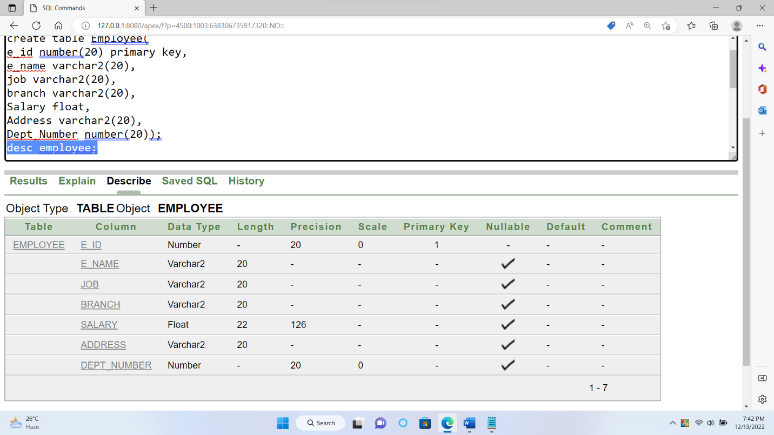

**DESCO TABLE:**

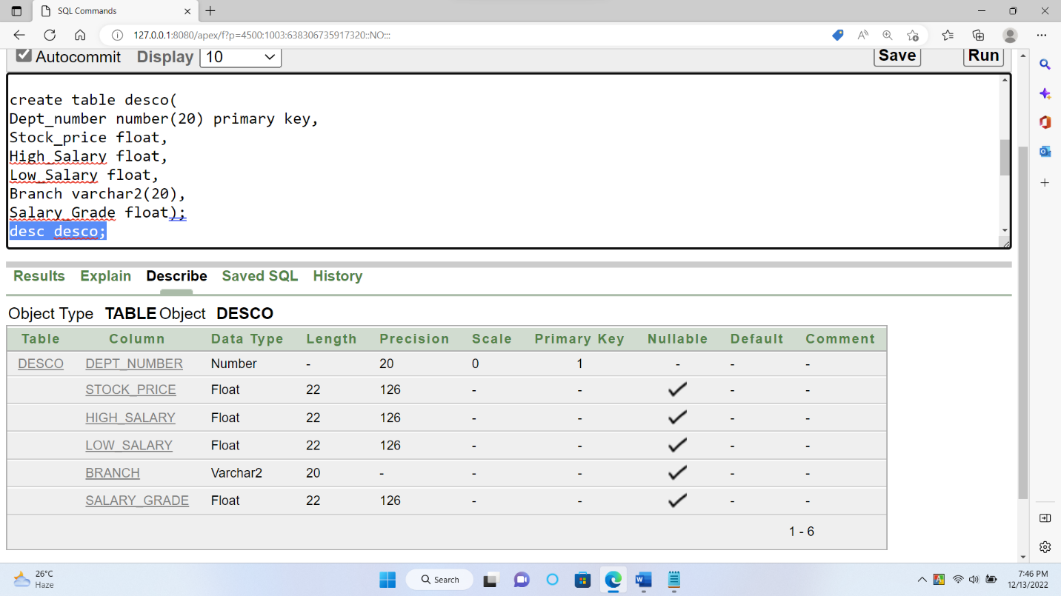

**USER TABLE:**

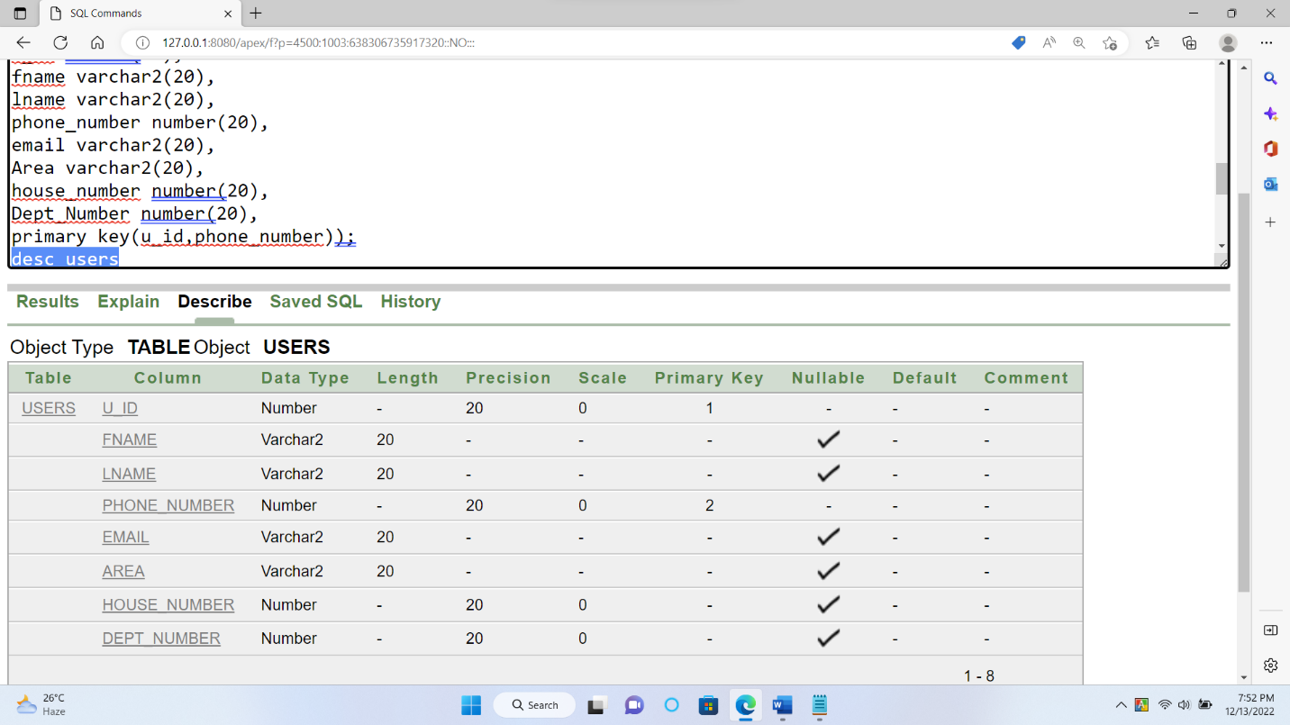

**ACCOUNT TABLE:**

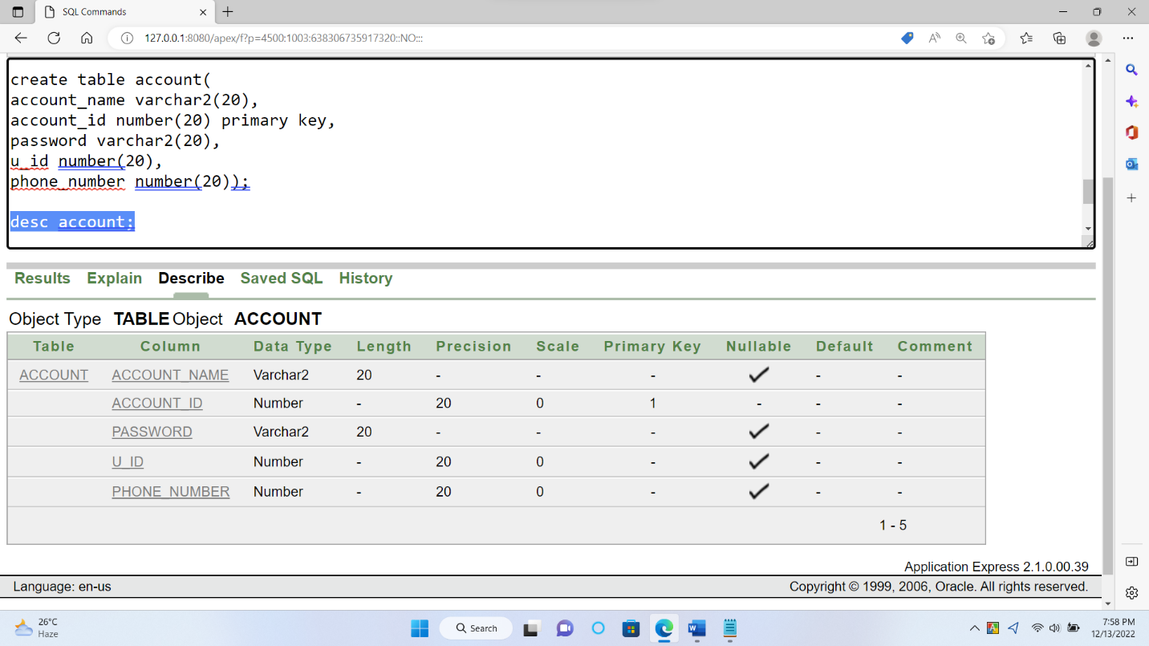

**CONNECTION TABLE:**

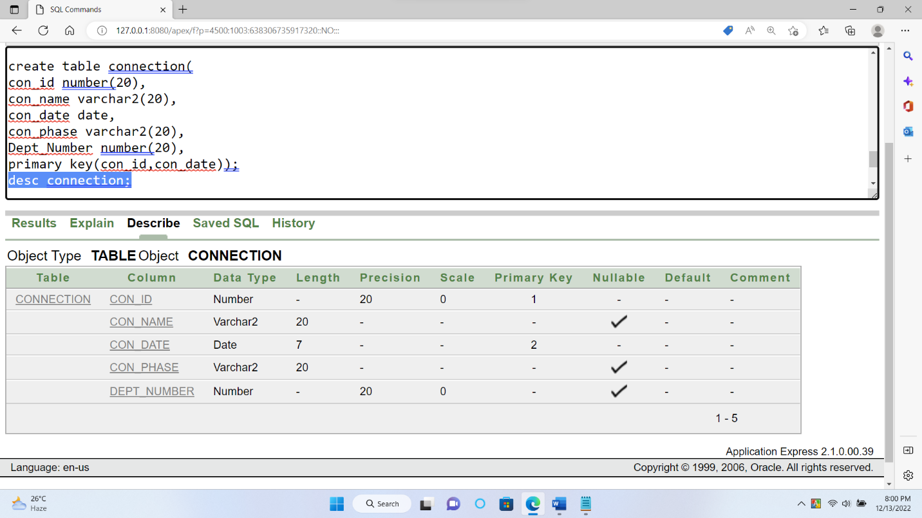

**CLEARANCE TABLE:**

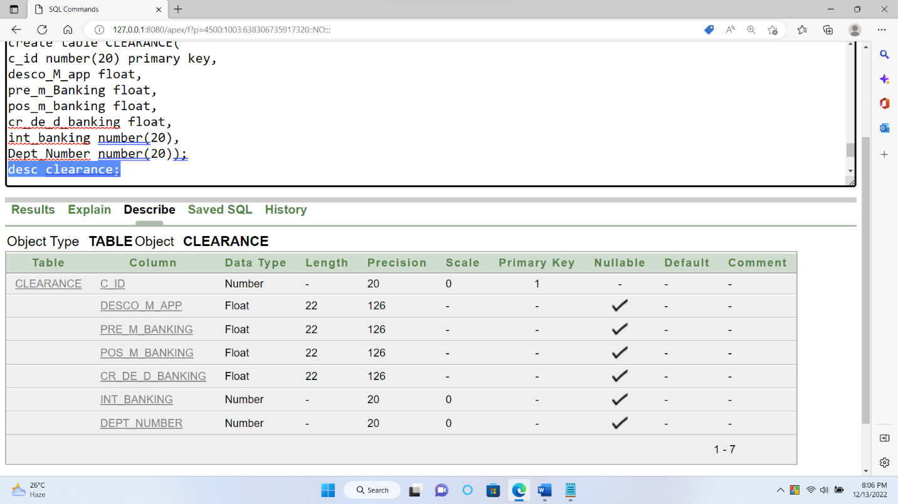

**DATA INSERTION**

**EMPLOYEE TABLE DATA INSERTION**

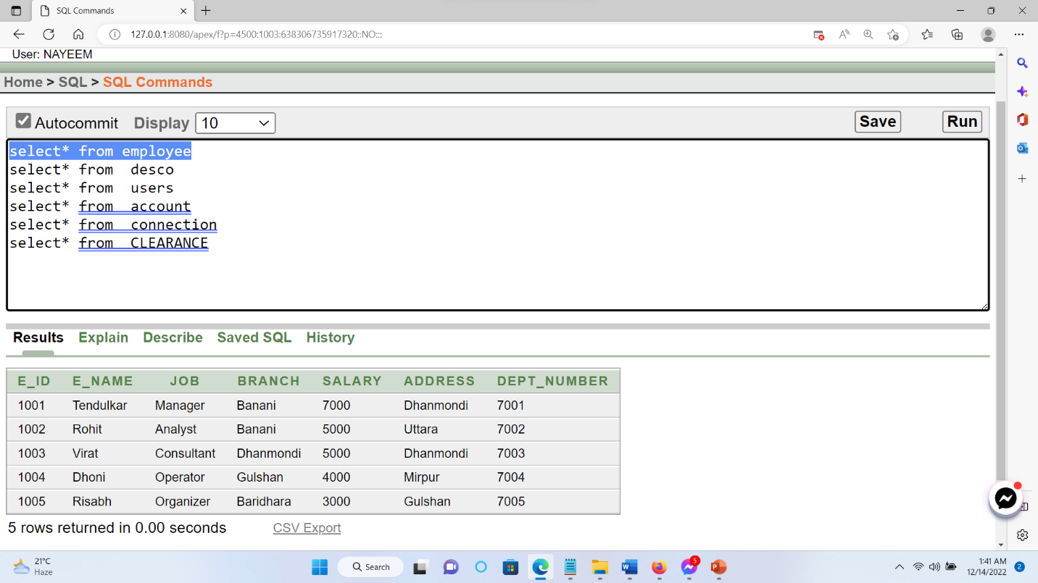

**DESCO TABLE DATA INSERTION**

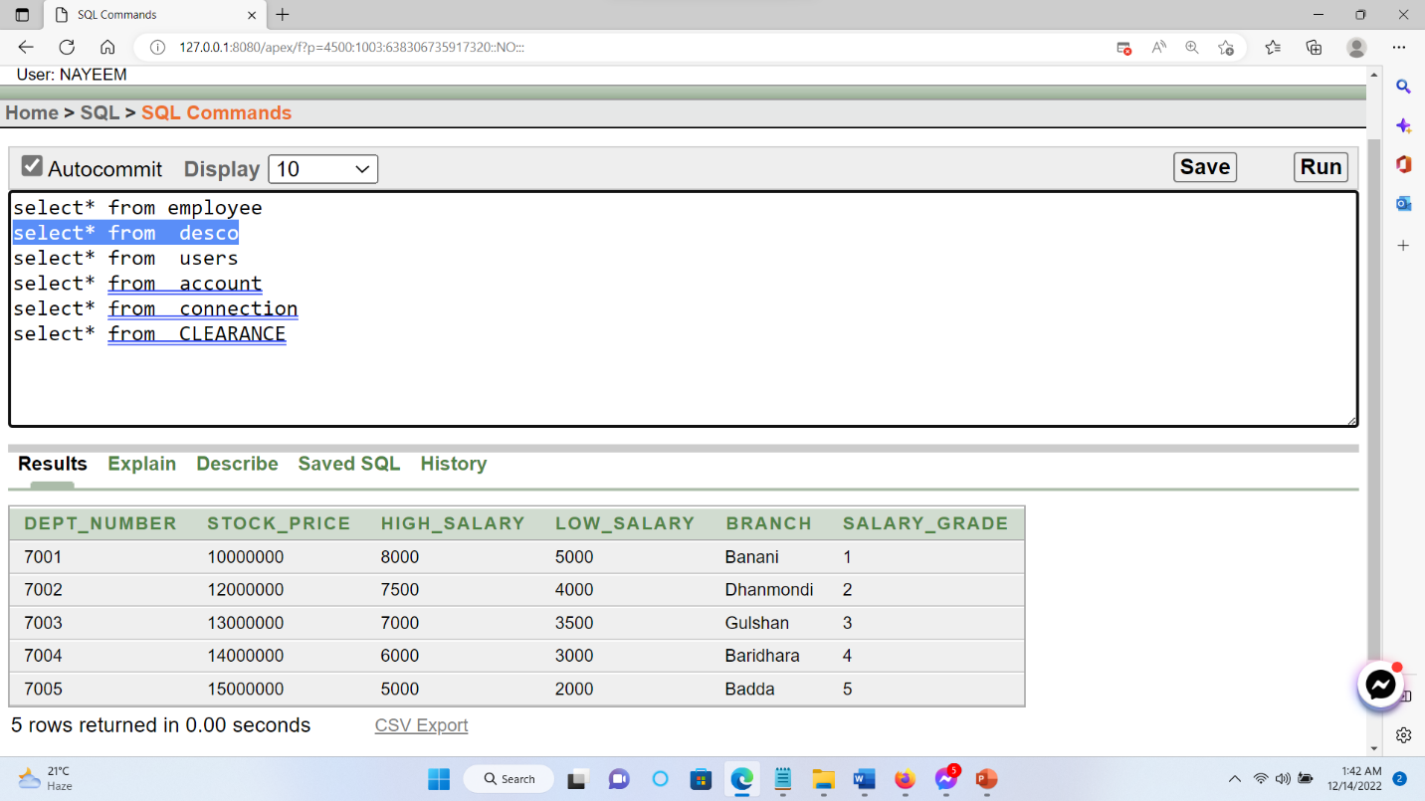

**USERS TABLE DATA INSERTION**

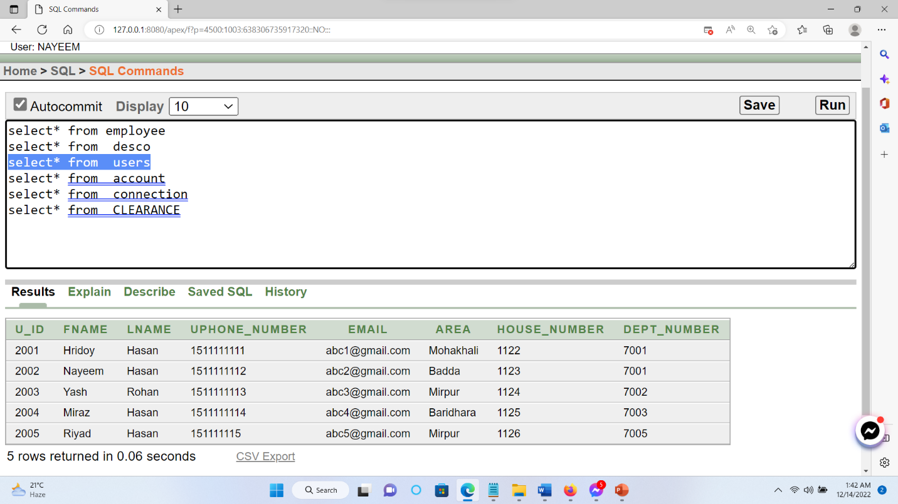

**ACCOUNT TABLE DATA INSERTION**

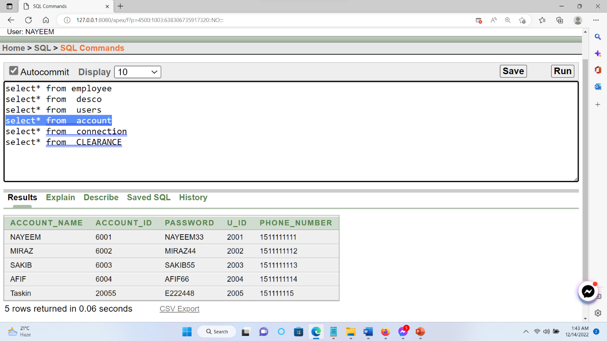

**CONNECTION TABLE DATA INSERTION**

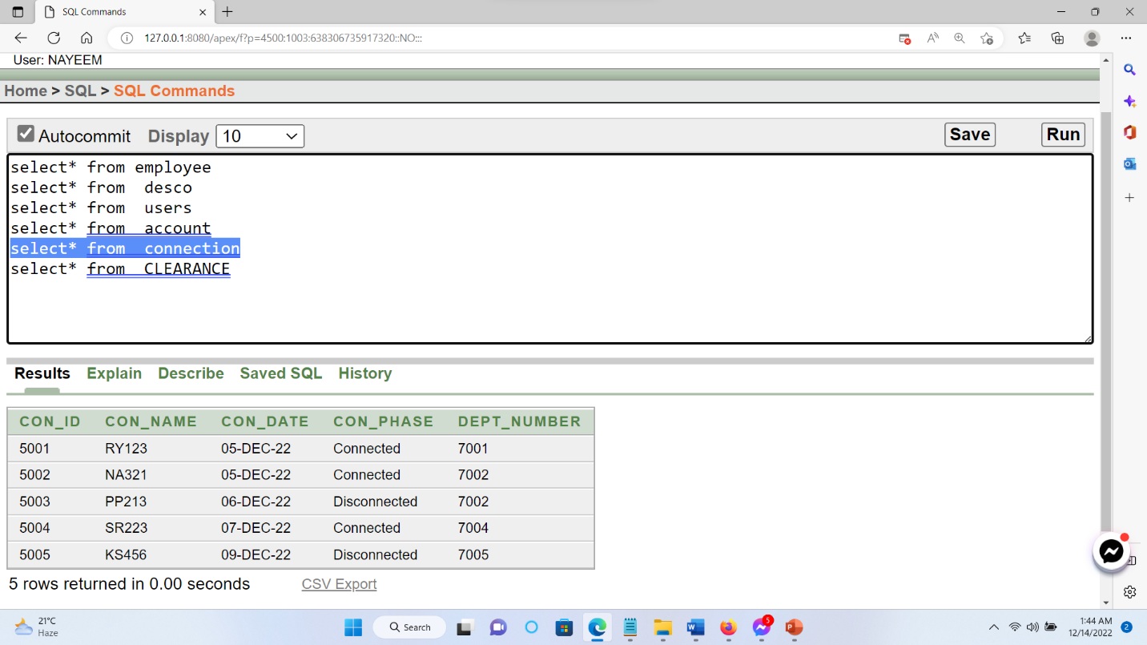

**CLEAREANACE TABLE DATA INSERTION**

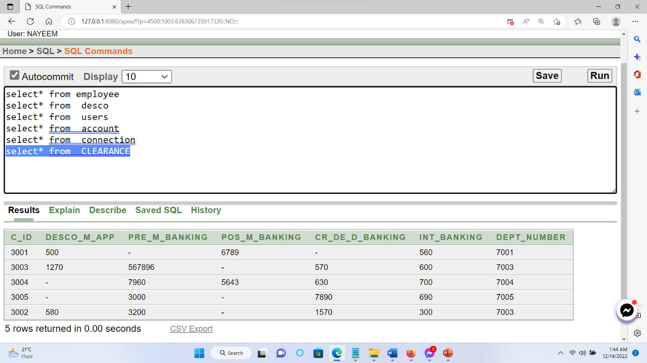

**JOINING**

**Equijoin 🡪1)** Display the employee id, employee name, address with the salary greed for all employee.

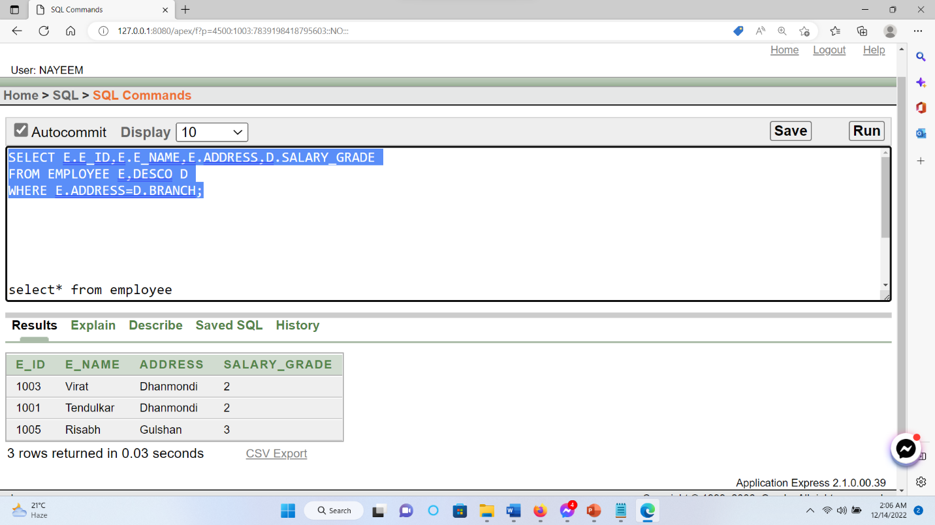

**Equijoin 🡪2**) Select all the users id, email, and their account id.

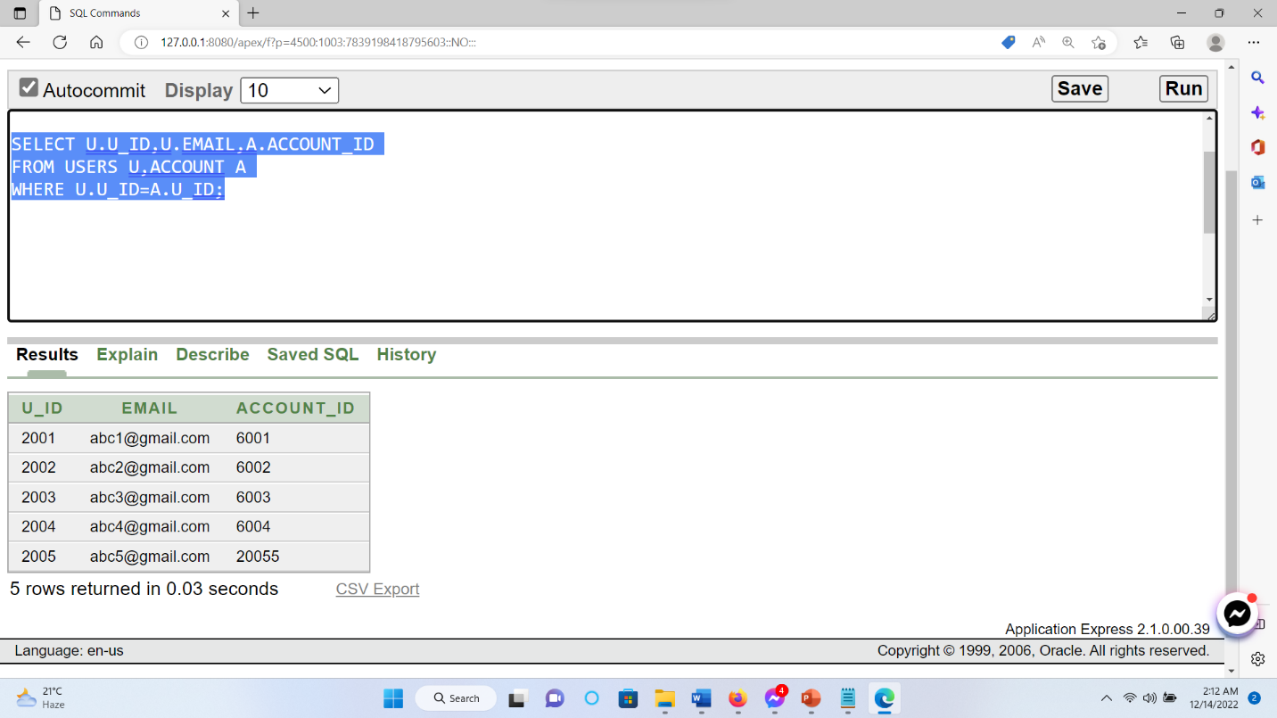

**Outer join🡪1)** Select clearance id and pre mobile banking amount with the high salary.

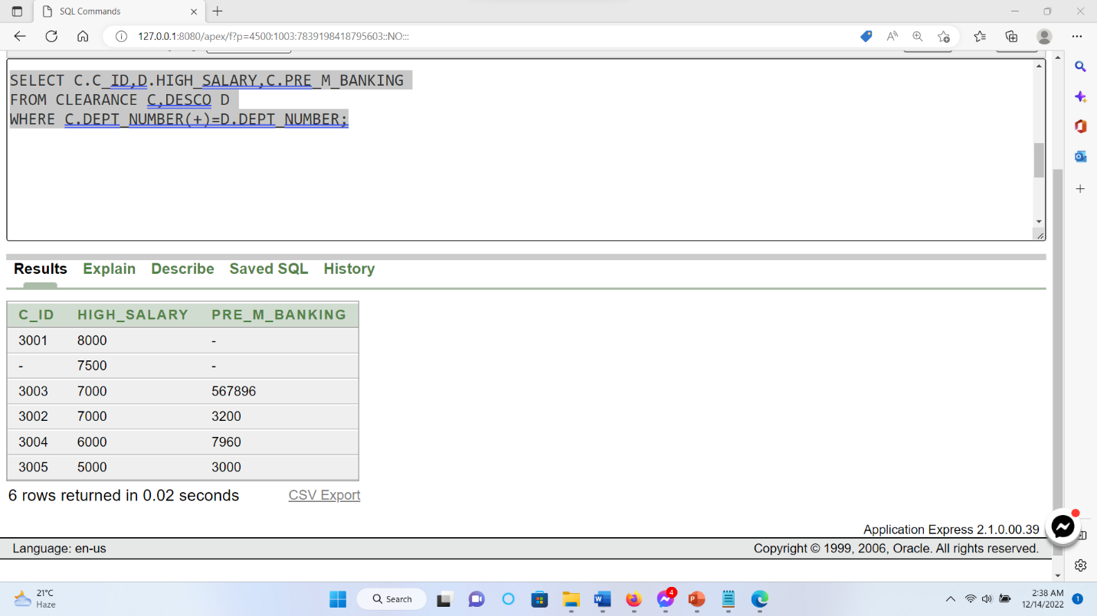

**Outer join🡪2)** Display the clearance id, branch name with salary greed and also display the high salary with pre mobile banking.

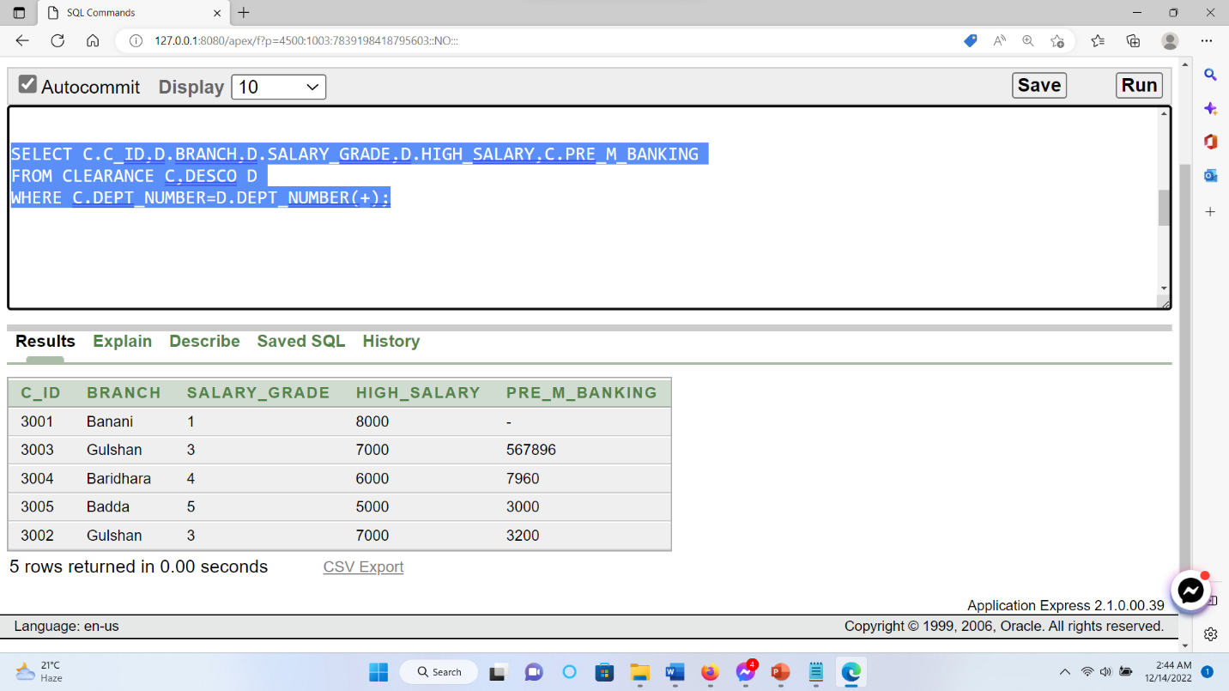

**Self-join 🡪1** Display the employee name and their branch name except the Dhanmondi branch.

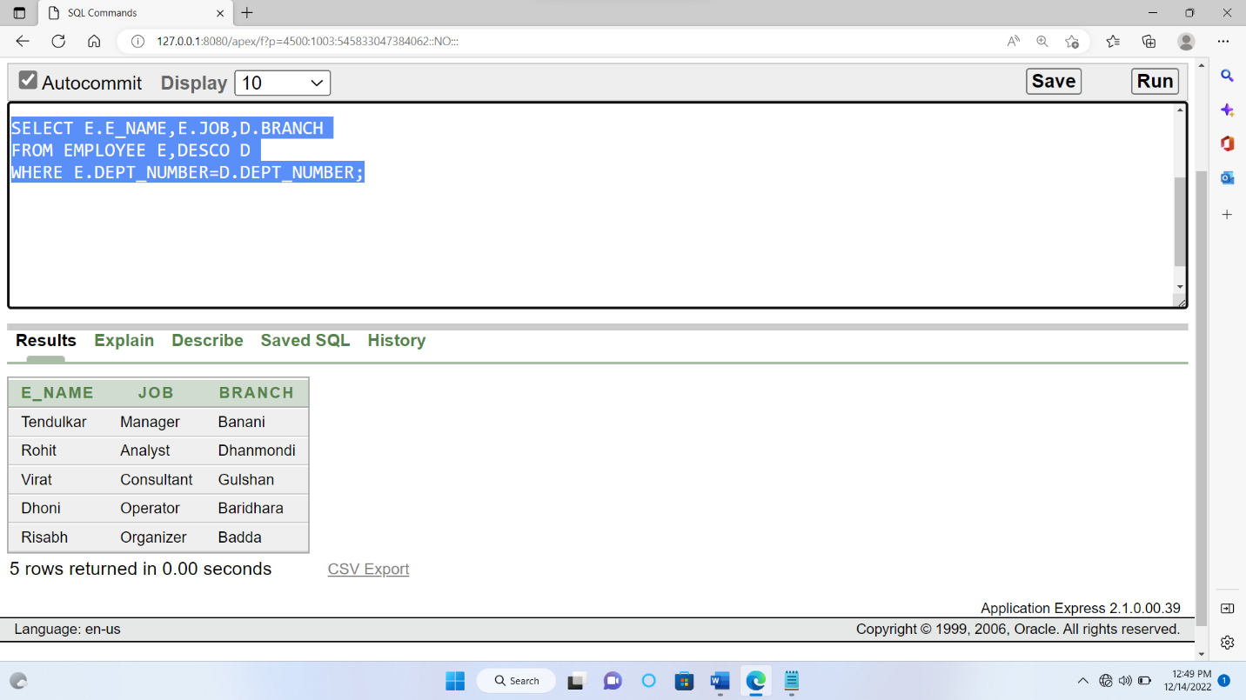

**Non-Equijoin🡪1) Display the employee id, employee branch and desco salary greed between low salary and high salary.**

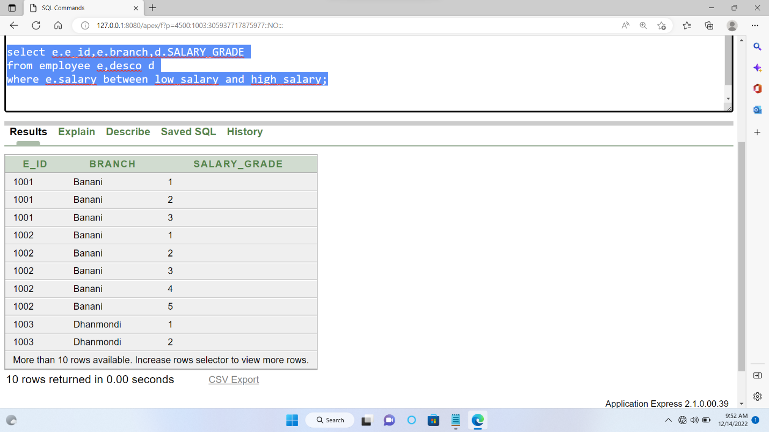

**Subquery**

**Subquery🡪**1) Display all the connection information and level the column con_ id connection id, con_name connection name, con_phase connection or disconnection**.**

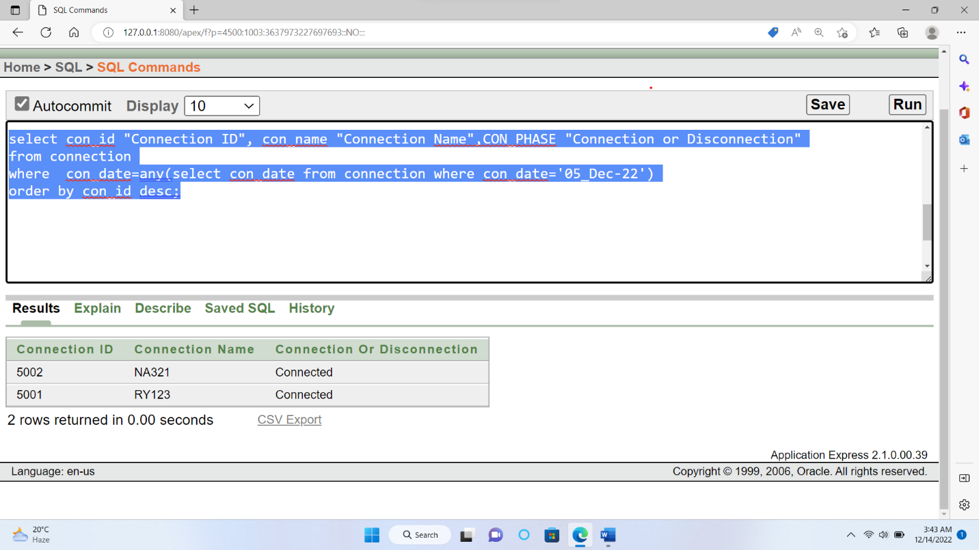

**Subquery🡪2 )** Select the first name, area and level the column name users name, Location where employee name is not equal Hridoys name. 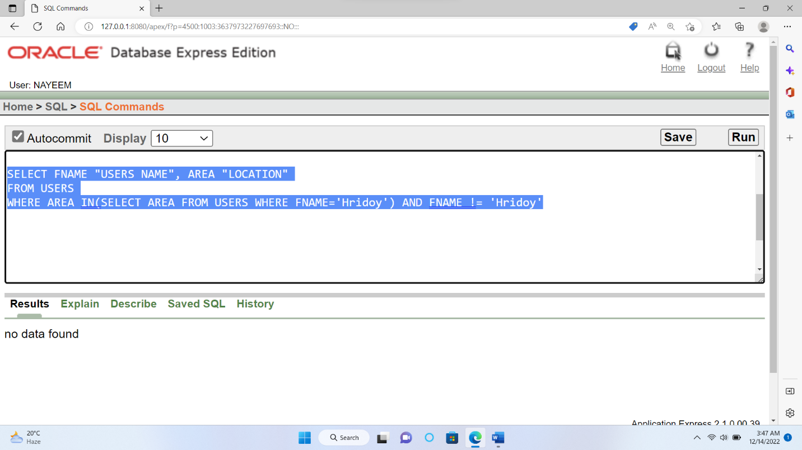

**Subquery🡪3)** Display the third maximum salary.

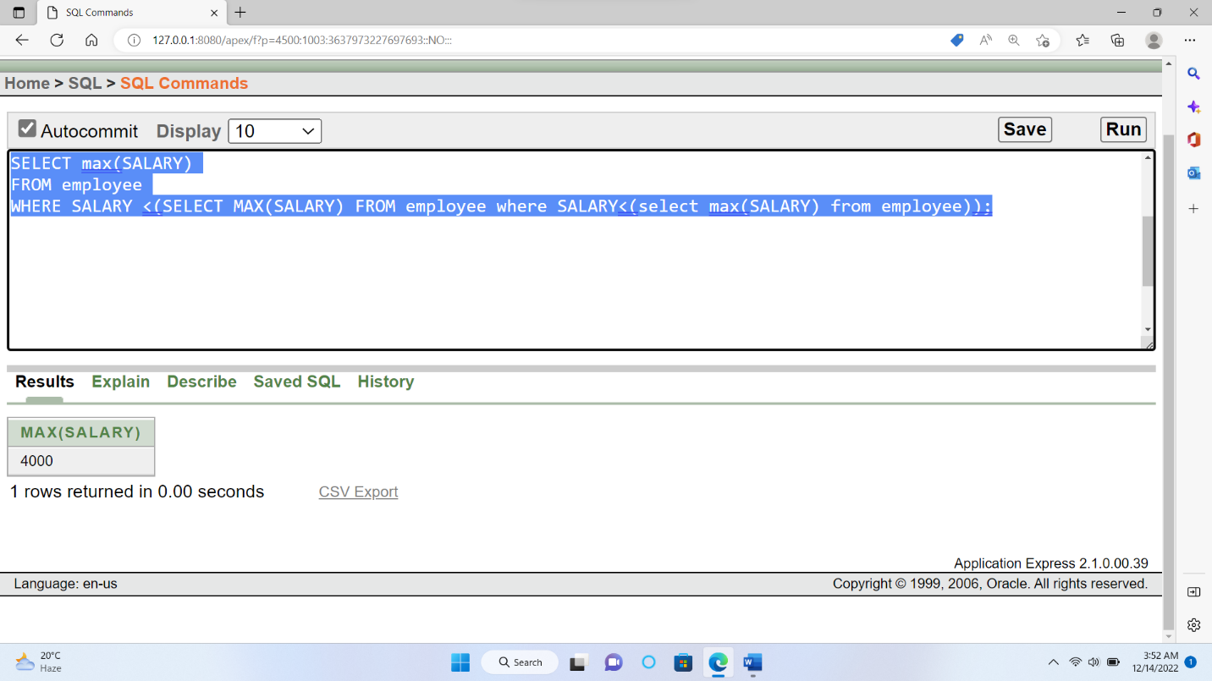

**Subquery🡪4**) Display the information all the Gulshan Branch.

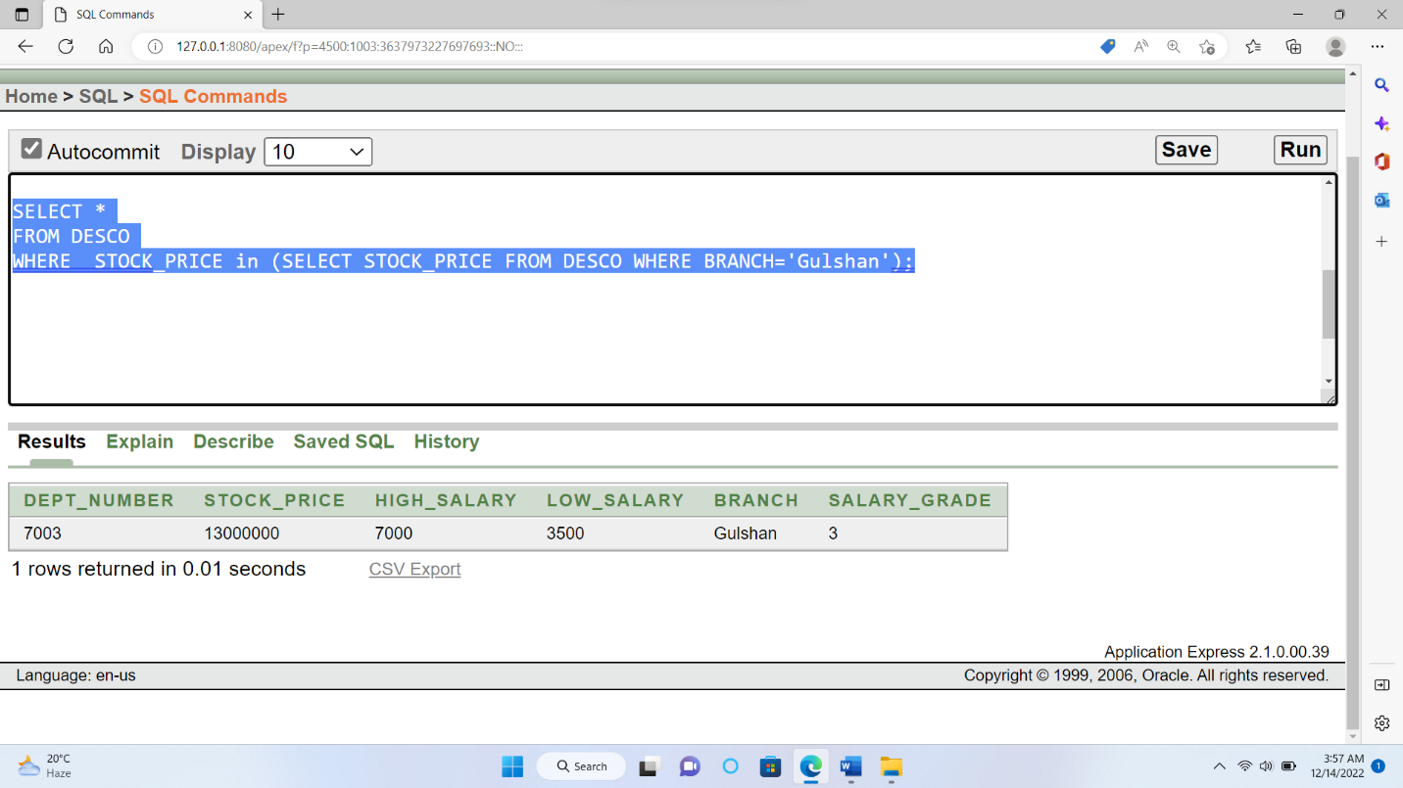

**VIEW**

**Simple view🡪1)** Create a view called CONVIEW based on the connection id, connection name and connection date**.**

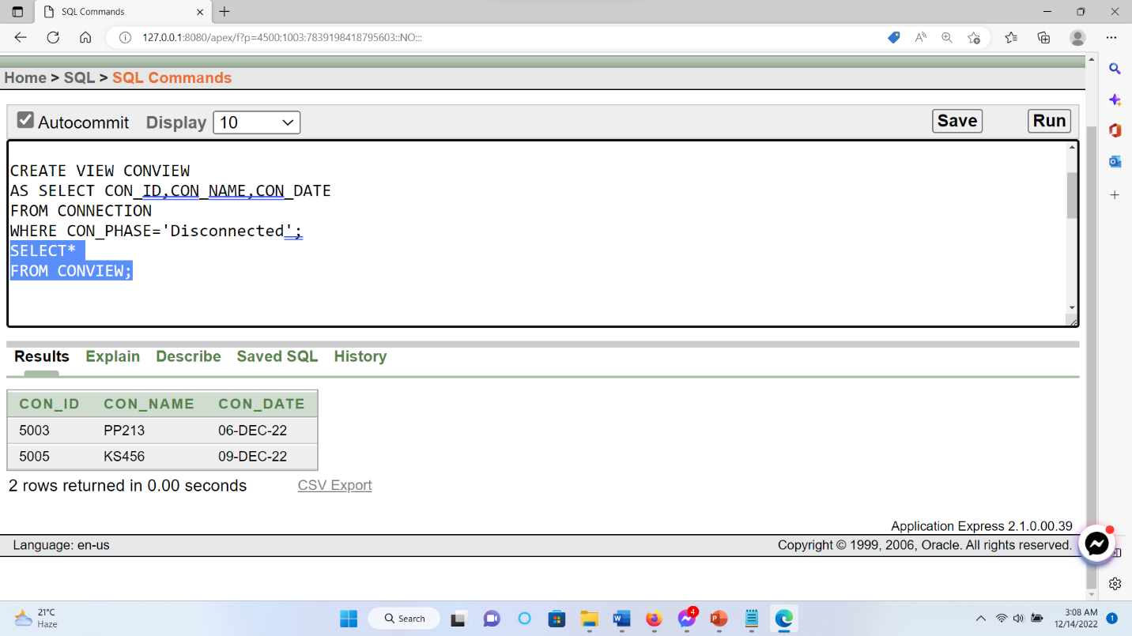

**Complex view 🡪1)** Create a view called employee_view based on average salary and level the Colum name as avg_salary**.**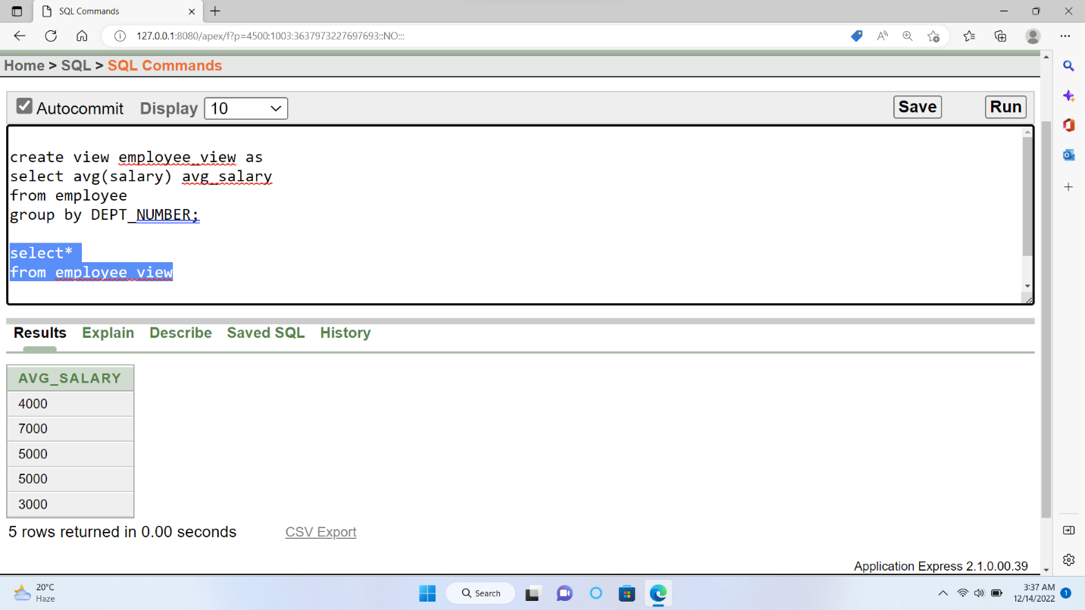

**CONSTRAIN**

1)Display the unique constraint Email.

